**Week 4 Ex-5-Output**

**1. Adding a Book**

**To add a book and check if it returns the correct status and custom header:**

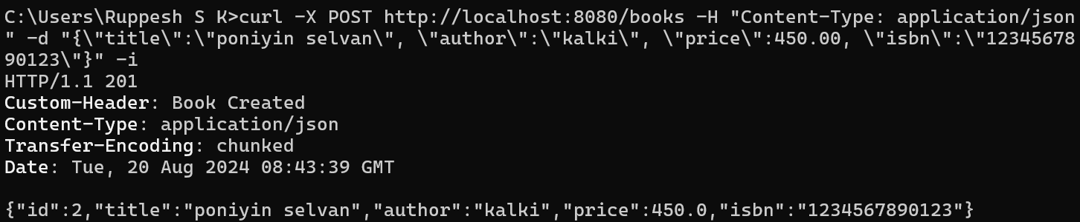

**2. Retrieving a Book by ID**

**To retrieve a book by its ID and check if it returns the correct status and custom header:**

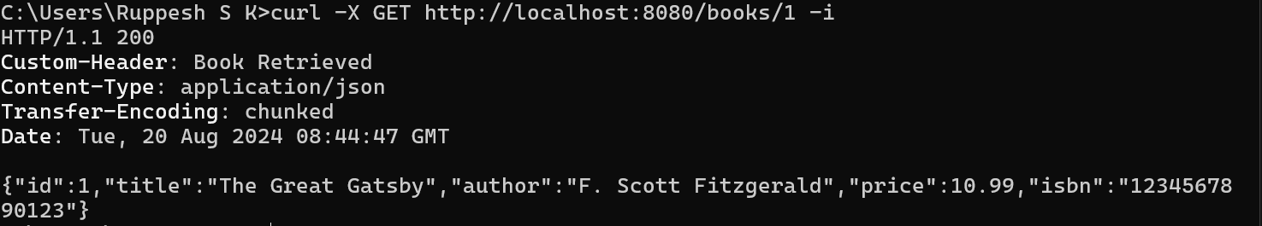

**4.Attempting to Retrieve a Non-Existent Book**

**To test the scenario where the book does not exist:**

